Fault Injection

Inject a 7-second delay **between reviews:v2 and ratings for user jason**.

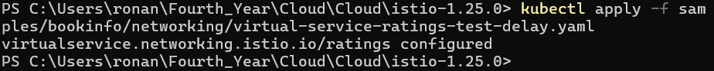

*Inject HTTP 500 Abort Fault to ratings for Jason*



